姓名 | 张健通
教育经历 | 2024至今，南方科技大学，自动化，本科在读
电子邮箱 | 12413111@mail.sustech.edu.cn
个人照片 | 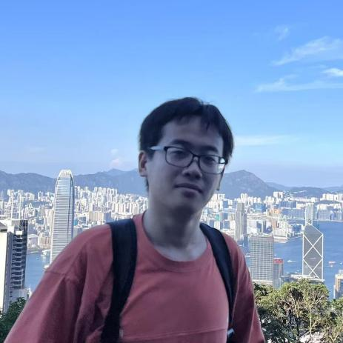
研究领域
自我介绍 | My name is Zhang Jiantong. I am an undergraduate student majoring in Automation at Southern University of Science and Technology. I would like to explore new things across different fields. Currently, I am focusing on robot navigation systems.
论文发表情况

